TD 3

1. SELECT FIRST_NAME AS "PRENOM" ,LAST_NAME AS "nom" FROM EMPLOYEES WHERE SALARY > (SELECT MAX(SALARY) FROM EMPLOYEES WHERE DEPARTMENT_ID = 60);
2. CREATE TABLE EMP_2 AS (SELECT FIRST_NAME, LAST_NAME, EMAIL FROM EMPLOYEES);

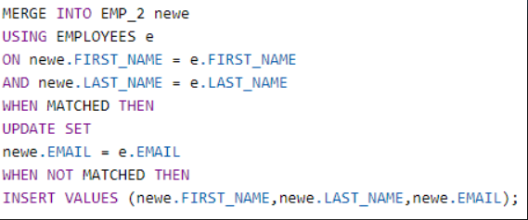

1. select e.last_name, hire_date,  
   (case  
   WHEN (SYSDATE-TO_YMINTERVAL('15-0'))>=HIRE_DATE THEN 'Plus de 15 années de services'  
   WHEN... 'Plus de 10'  
   WHEN ...'Plus de 5'  
   ELSE 'Pas encore'  
   END) as "total"  
   from hr.EMPLOYEES e;

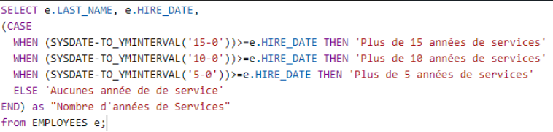

1. 
2. 